**Week 5 Ex-10-Output**

**1. Create a Book:  
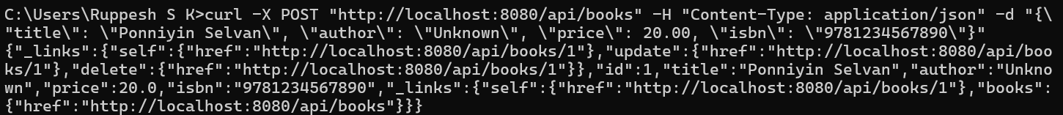**

**2. Retrieving Book by (JSON):**

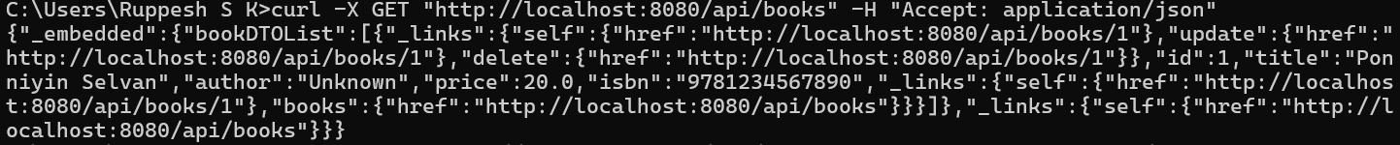

**3. Retrieving Book by (XML):  
  
